Project 1 - Relational Algebra

Bradley Harper

CSC 3300 Databases

Dr. Kubiak

1. πcourse_id, sec_id (σsemester = 'Spring' ∧ year = 2009 ∧ section.sec_id < 2 (course ⨝ section))
2. πgrade (student ⨝ takes) or just πgrade ( takes)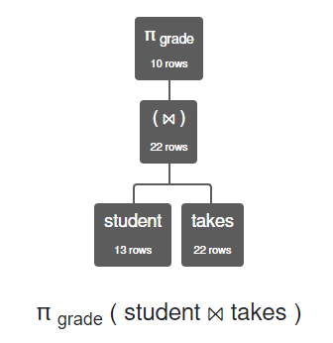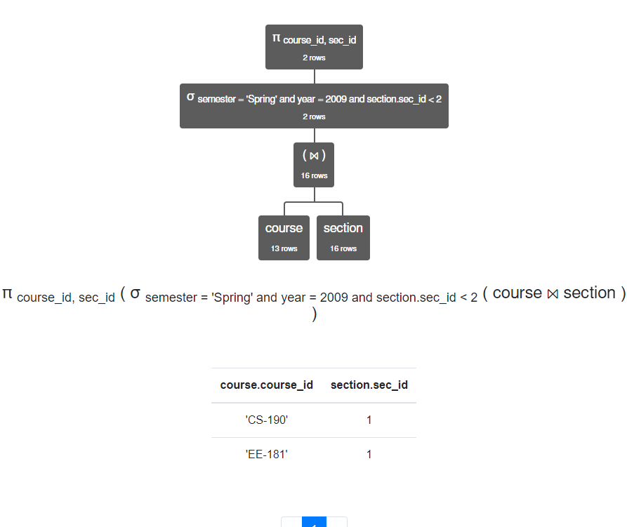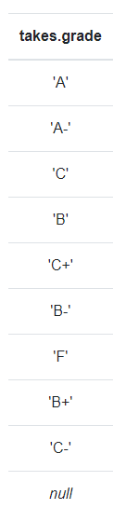
3. πID (instructor) ∩ πi_id (advisor) 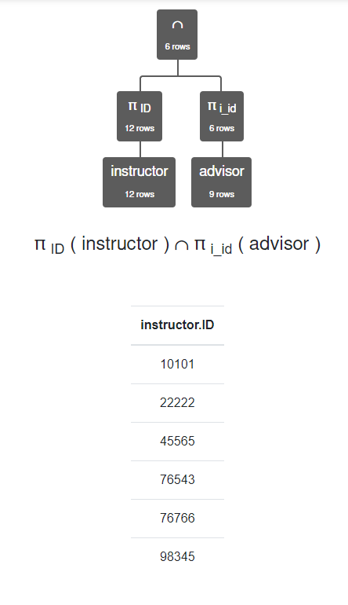
4. πcourse_id, sec_id (σname = 'Srinivasan' ∧ semester = 'Fall' ∧ year = 2009 (instructor ⨝ teaches))

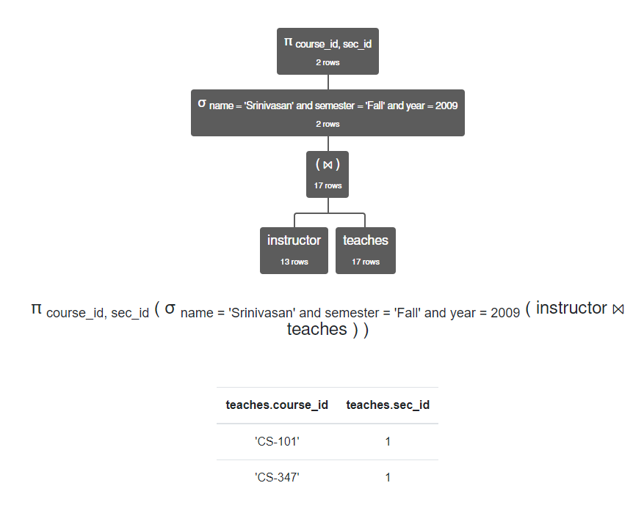

1. πID, name (σinstructor.dept_name ≠ course.dept_name ∧ teaches.course_id = course.course_id ((instructor ⨝ teaches) ⨯ course))

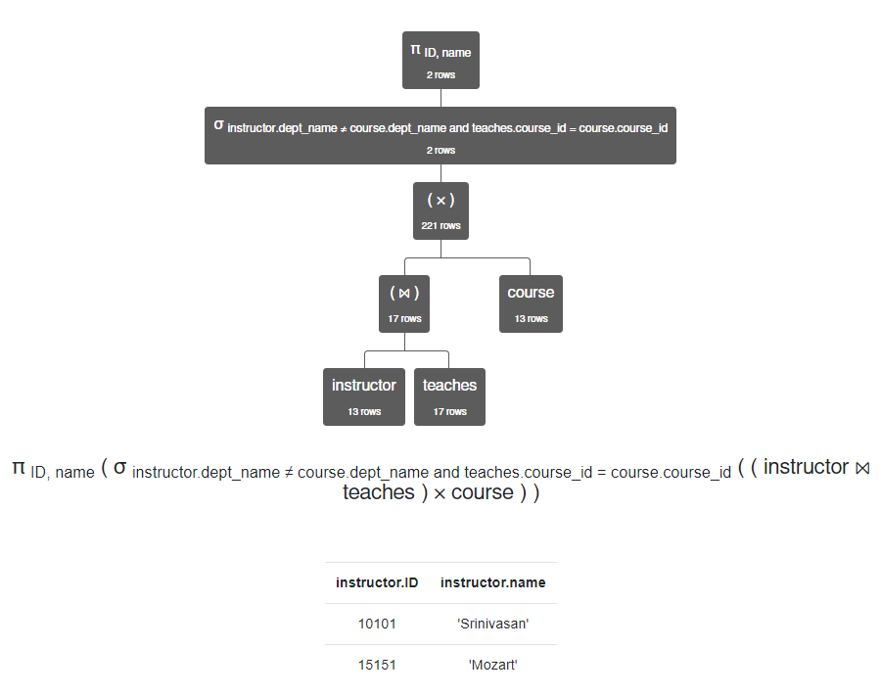

1. πID, name (σi_id = null ∧ s_id = ID (student ⨝ advisor))

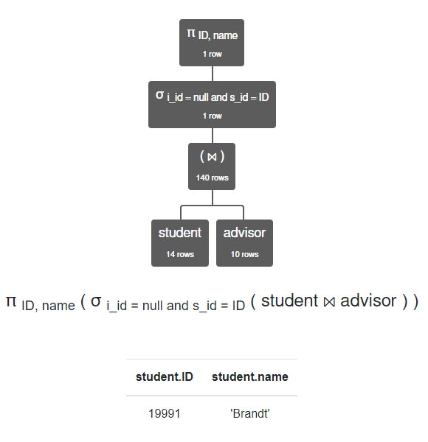

1. πcourse.course_id, course.title (σsemester = 'Spring' ∧ year = 2010 (course ⨝ section))

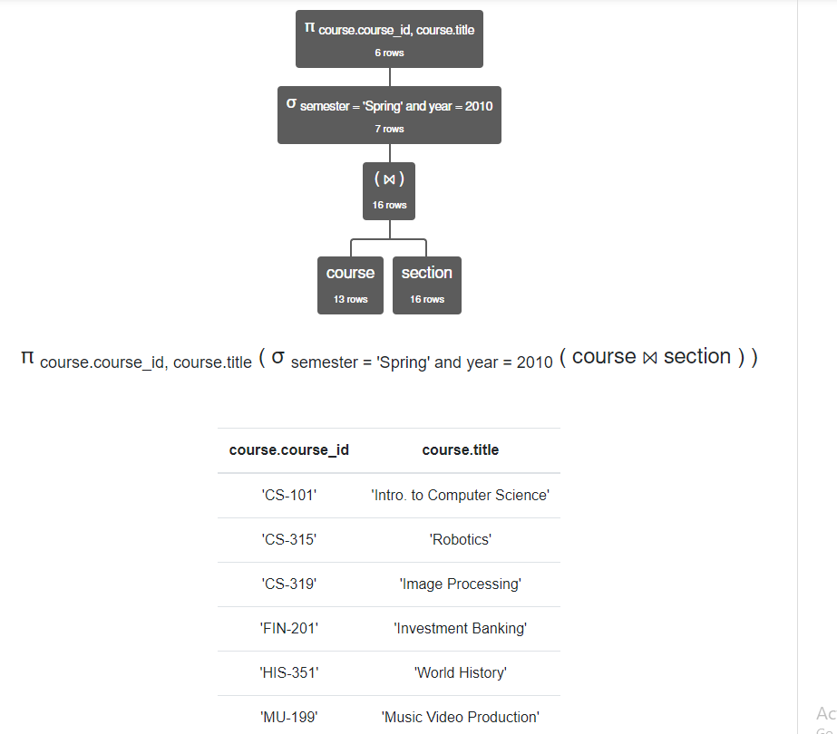

1. πcourse_id (course) ∩ πcourse_id (prereq)

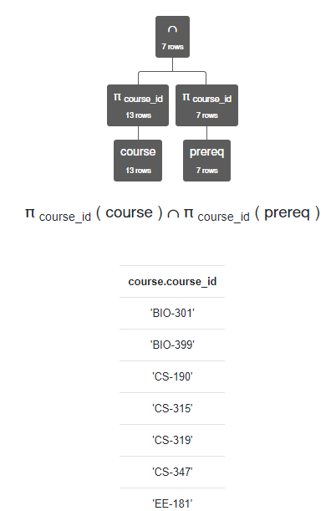

1. πcourse.course_id, course.title, course.dept_name (σT1.dept_name ≠ course.dept_name ∧ course.course_id ≠ T1.course_id ∧ T1.course_id = prereq.prereq_id ((course ⨝ prereq) ⨯ ρT1 course))

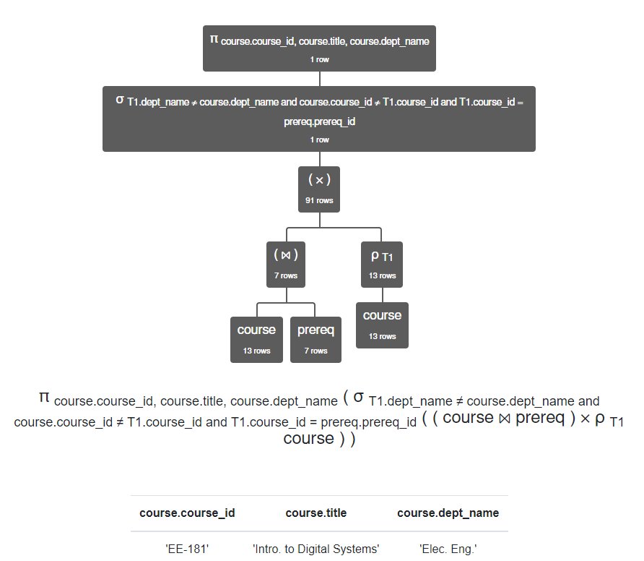

1. πstudent.ID, student.name (σgrade = 'A' ∧ course_id = 'CS-190' ∧ semester = 'Spring' ∧ year = 2009 (student ⨝ takes))

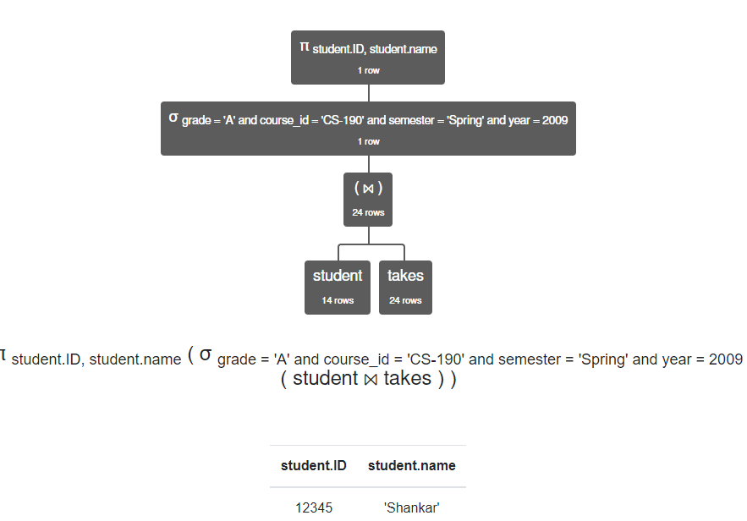

1. πcourse_id, sec_id, semester, year (student ⨝ takes) - πcourse_id, sec_id, semester, year (instructor ⨝ teaches)

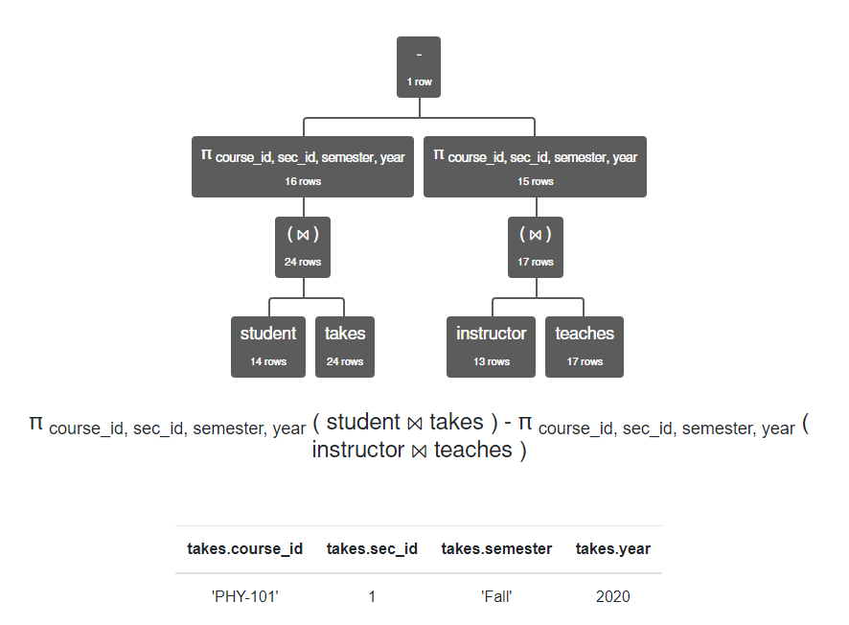

1. πT1.building, T1.room_number (σT1.room_number ≠ T2.room_number ∧ T1.capacity ≤ T2.capacity ∧ T2.capacity ≤ T1.capacity (ρT1 classroom ⨯ ρT2 classroom))

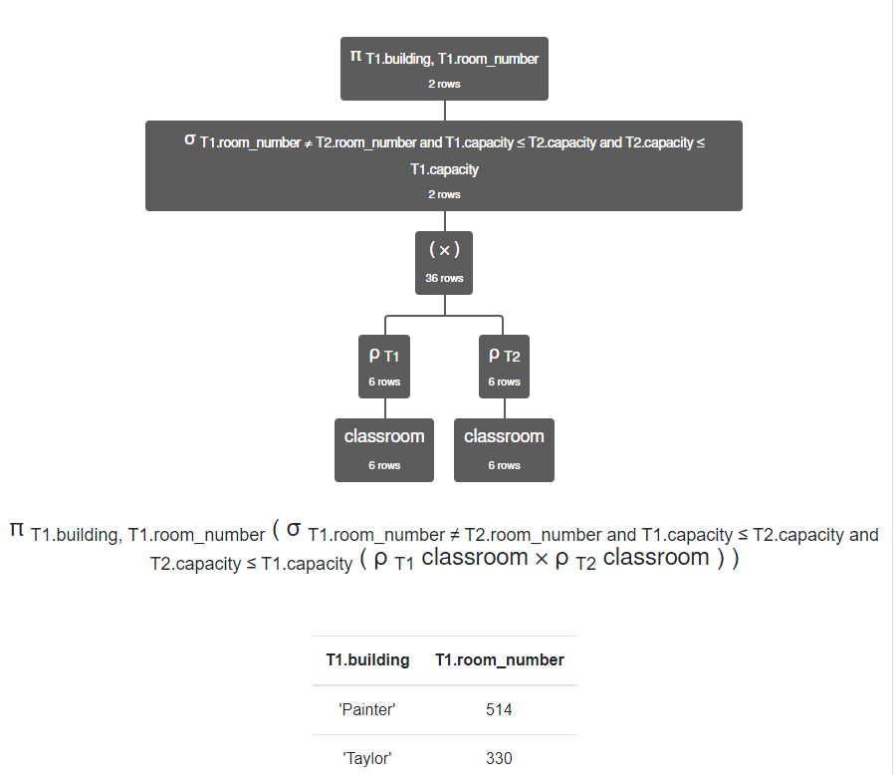

1. πstudent.ID, student.name (σstudent.name = instructor.name (student ⨯ instructor))

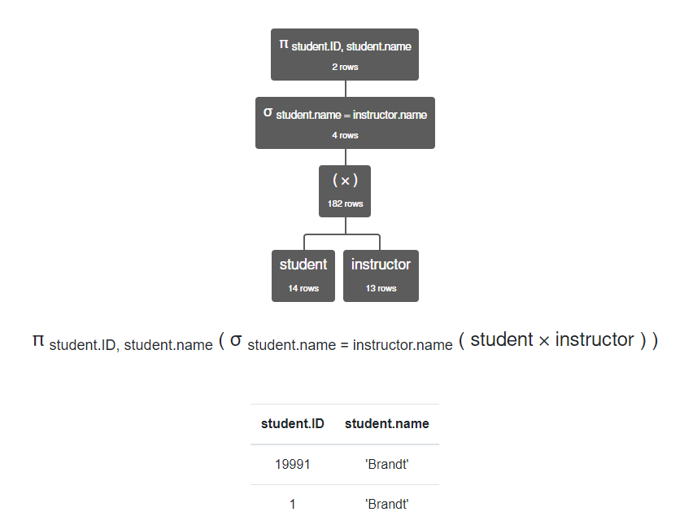

1. πstudent.ID, student.name (σadvisor.s_id = student.ID ∧ advisor.i_id = teaches.ID ∧ takes.course_id = teaches.course_id ∧ takes.year = teaches.year ∧ takes.semester = teaches.semester ∧ takes.sec_id = teaches.sec_id ((student ⨝ takes) ⨯ advisor ⨯ (teaches)))

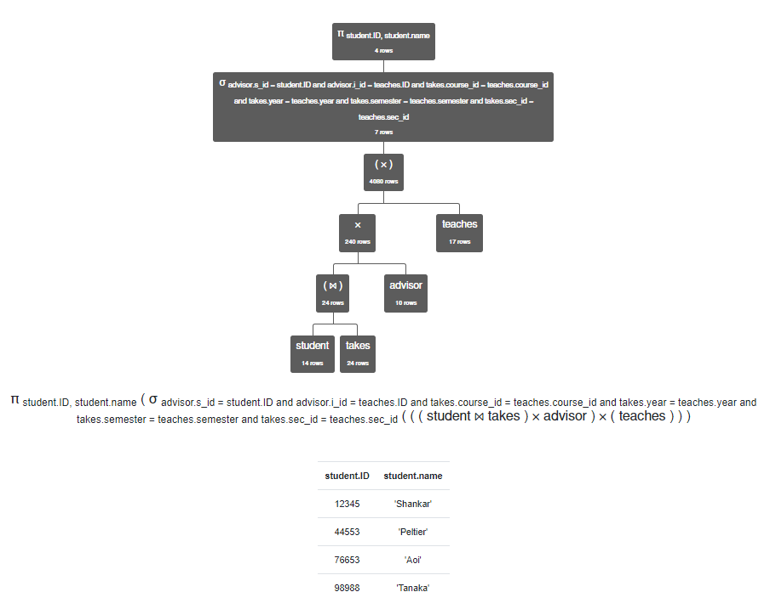

1. πstudent.name, student.ID (σteaches.ID = 15151 ∧ takes.course_id = teaches.course_id ∧ takes.sec_id = teaches.sec_id ((student ⨝ takes) ⨯ teaches))

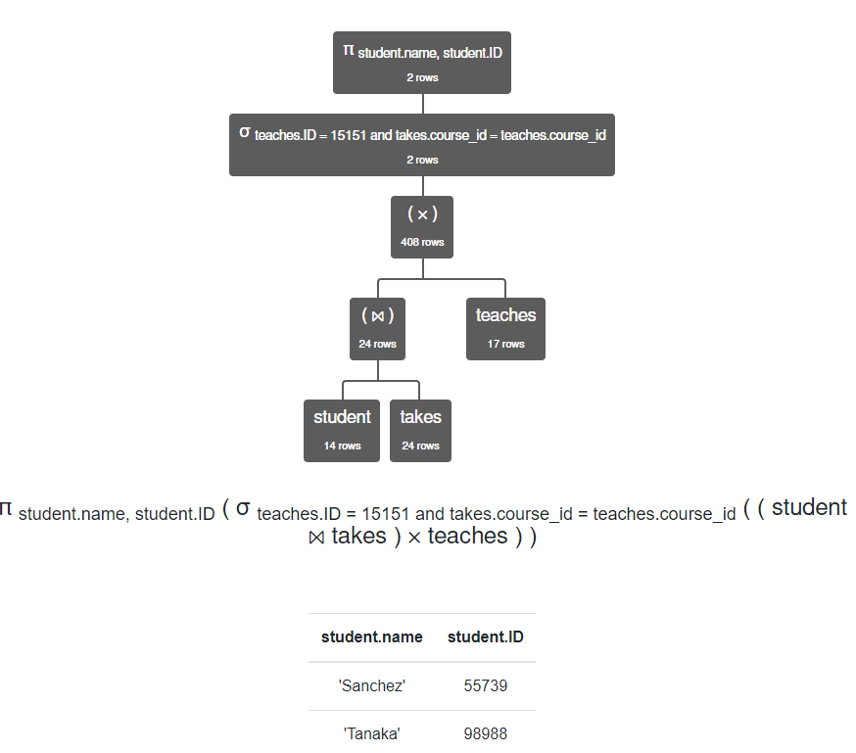

1. πname (σcourse_id = 'CS-315' (student ⨝ takes)) ∩ πname (σcourse_id = 'CS-347' (student ⨝ takes)) ∩ πname (σgrade = 'A' (student ⨝ takes))

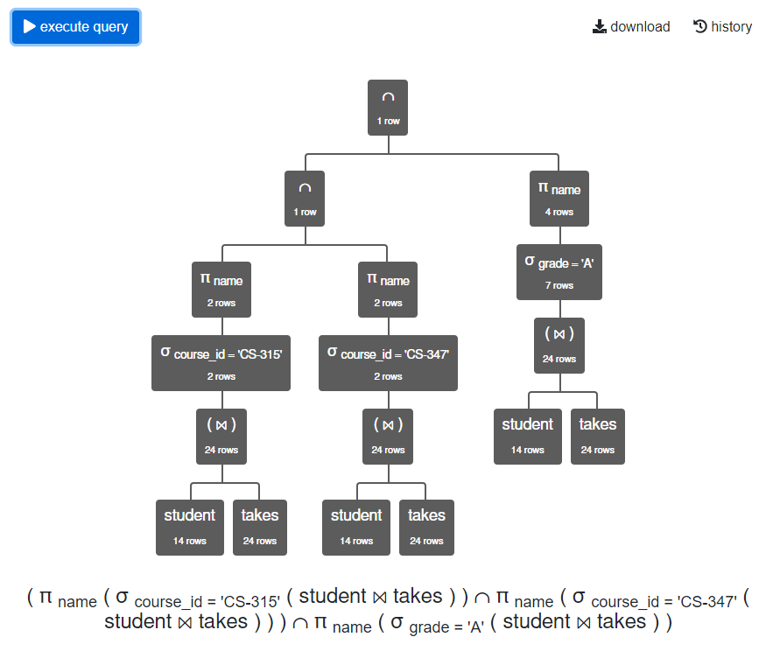

1. πT1.course_id, T1.sec_id (σT1.semester = T2.semester ∧ T1.year = T2.year ∧ T1.course_id = T2.course_id ∧ T1.sec_id = T2.sec_id ∧ T1.ID < T2.ID (ρT1 teaches ⨯ ρT2 teaches))

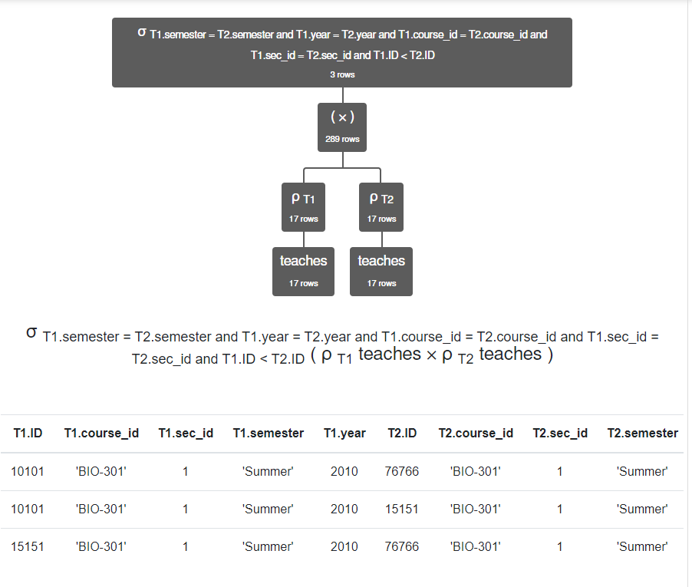

1. πcourse.course_id (course) - π section.course_id (section)

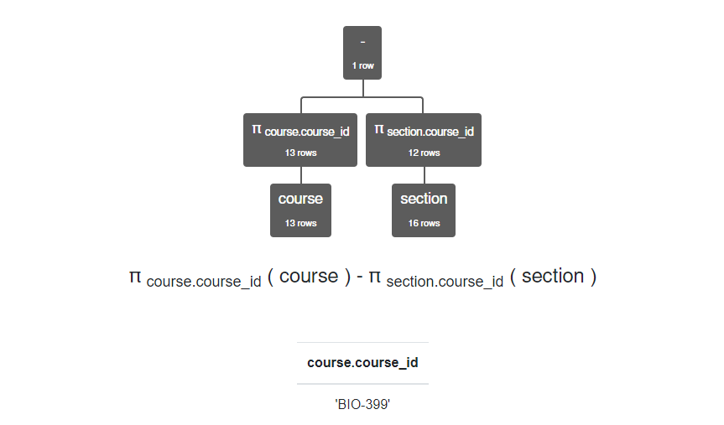

1. πbuilding (σname = 'Brown' ∧ semester = 'Spring' ∧ year = 2010 (student ⨝ classroom ⨝ takes)) 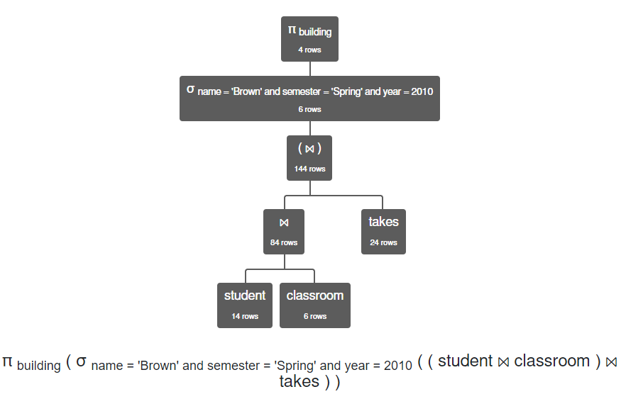
2. πstudent.name, student.ID (σinstructor.name = 'Gold' ∧ takes.course_id = teaches.course_id ∧ takes.sec_id = teaches.sec_id ((student ⨝ takes) ⨯ (teaches ⨝ instructor)))

